Module-3

(C Programming)

1.Display This Information using printf.

(A) Your Name (B) Your Birth date (C) Your Age (D) Your Address

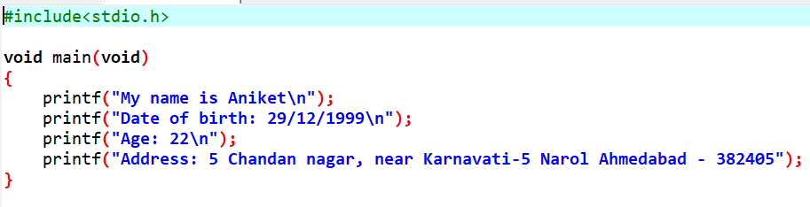

2. Write a program to make addition, Subtraction, Multiplication and Division of Two Numbers.

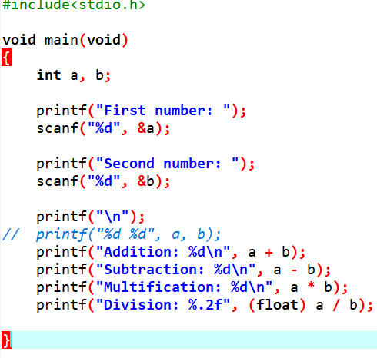

3. Write a program to make a square and cube of number.

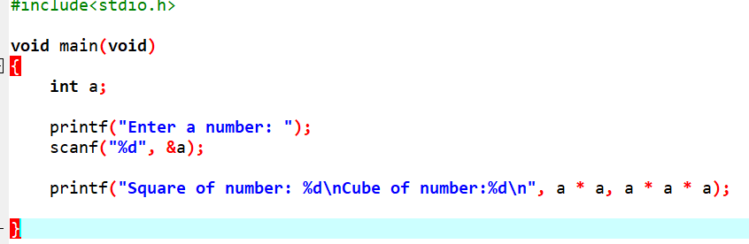

4. Write a program to find the Area of Circle.

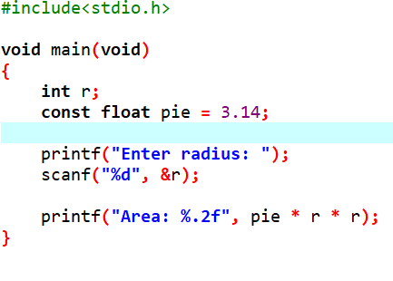

5. Write a program to find the Area of Triangle.

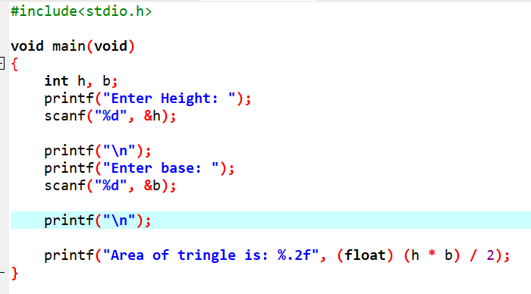

6. Write a program to find the simple Interest.

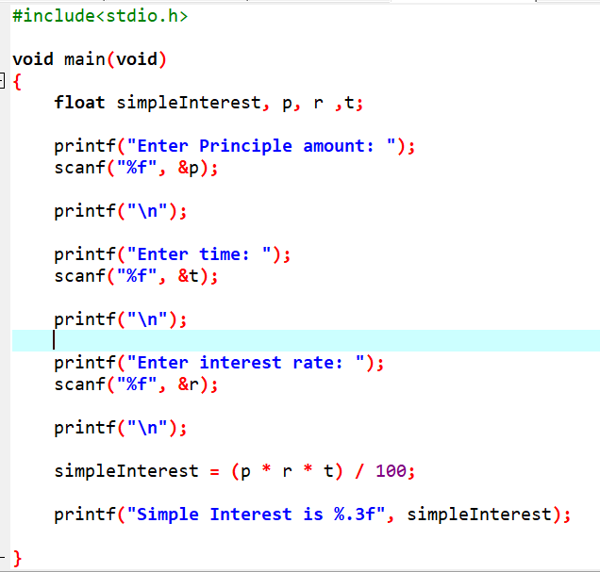

7. Write a program to convert temperature from degree centigrade to Fahrenheit.

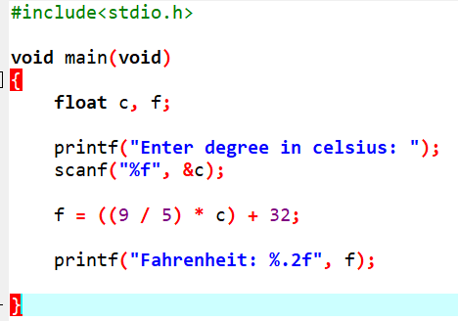

8. Write a program to calculate sum of 5 subjects & find the percentage. Subject marks entered by user.

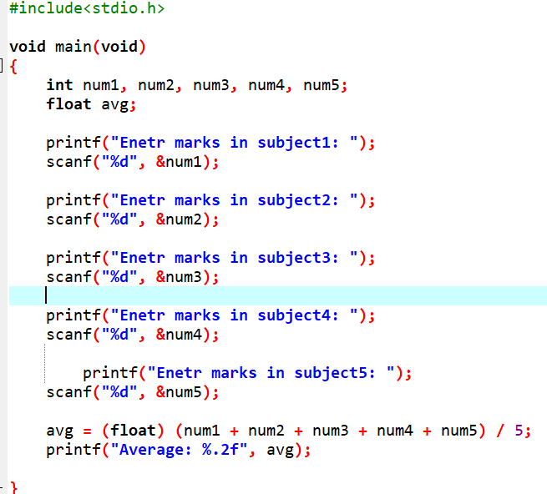

9. Write a Program to show swap of two No's without using third var.

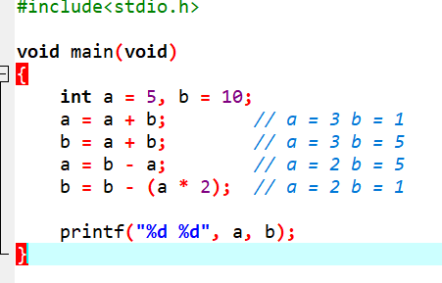

10. Write a Program to check the given number is Positive, Negative.

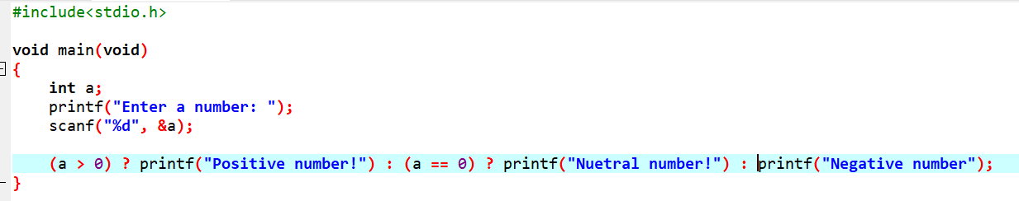

11.Write a Program to check the given year is leap year or not.

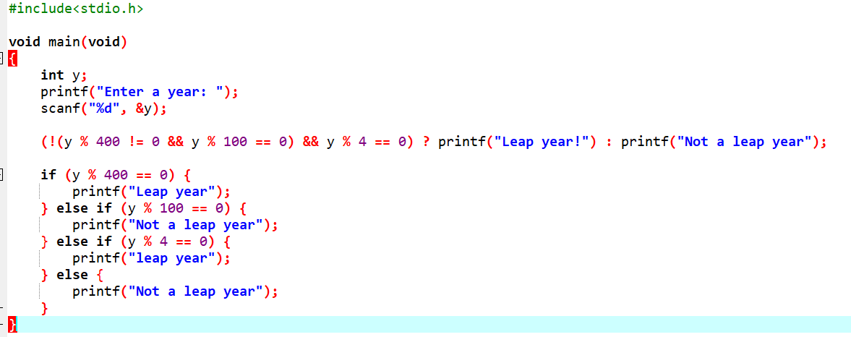

12. Write a Program to check the given number is Positive, Negative.



13.Write a program to find the Max number from the given three number using Nested If

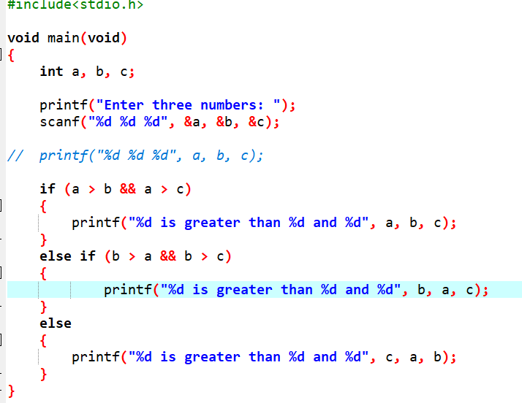

14. Write a program to find the Max number from the given three number using Ternary Operator

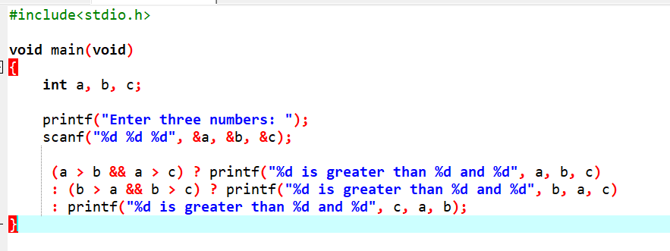

15. Write a program user enter the 5 subjects mark. You have to make a totaland find the percentage.

Percentage > 75 you have to print“Distinction” Percentage > 60 and percentage <= 75 you have to print “Firstclass” Percentage >50 and percentage <= 60 you have to print “Second class” Percentage > 35 and percentage <= 50 you have to print “Pass class” Otherwise print“Fail”

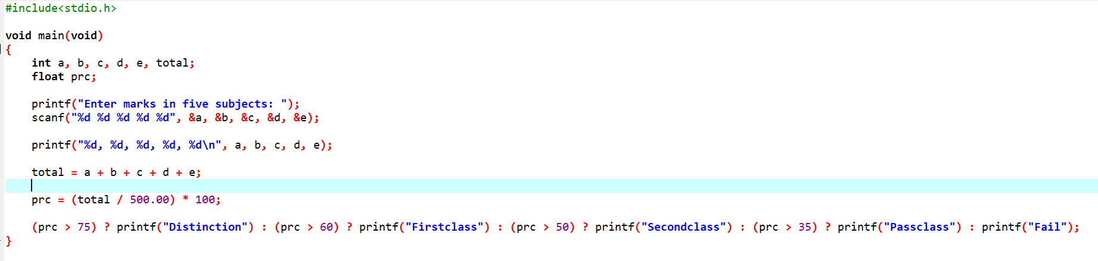

16. Write Program use switch statement. Display Monday to Sunday

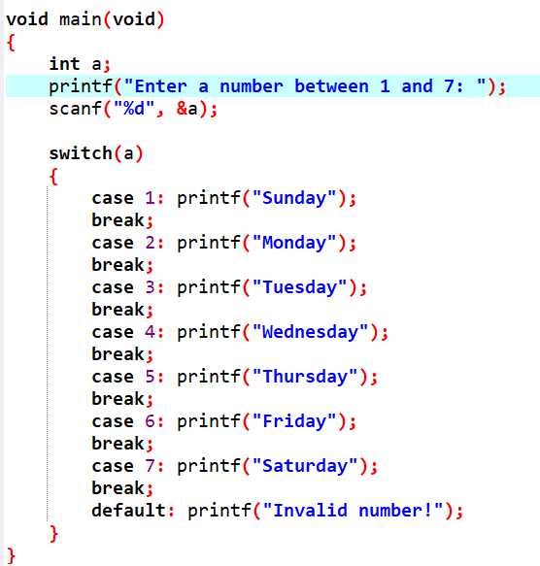

17. Write a Program of Addition, Subtraction ,Multiplication and Division using Switch case.(Must Be Menu Driven)

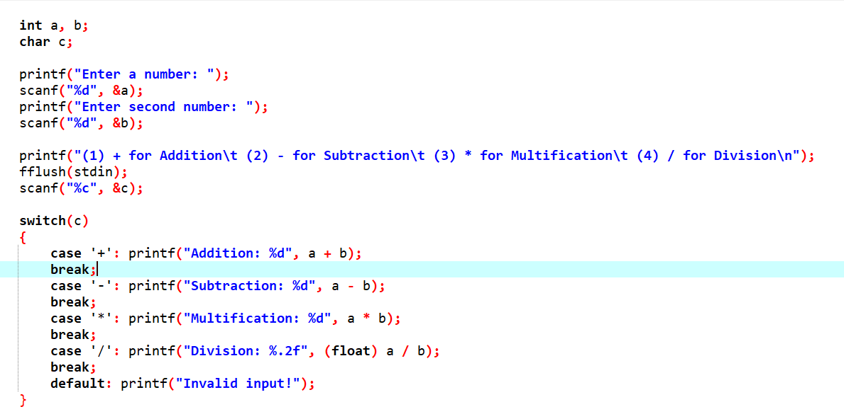

18.Write a program of to find out the Area of Triangle, Rectangle and Circle using If Condition. (Must Be MenuDriven)

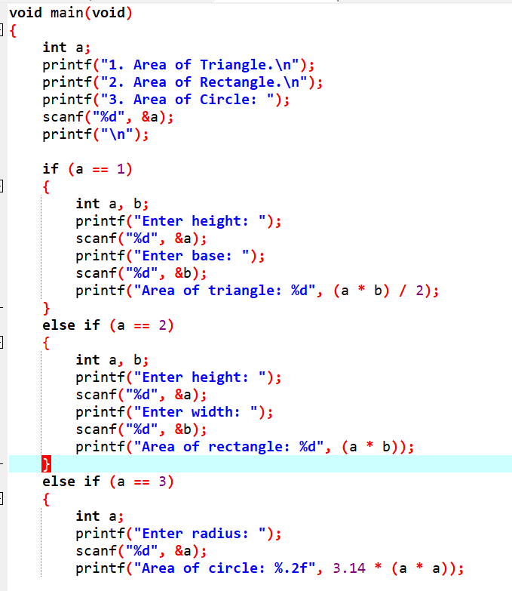

19. Looping Programs

A. Write a program to print the 1 to 10 using for loop.

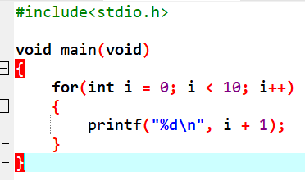

B. Write a Program to print the 51 to 60 using while loop

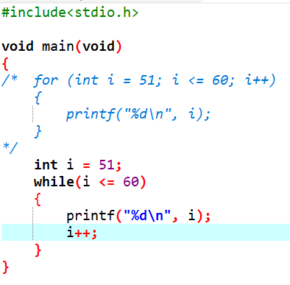

C. write a program to print the 100 to 81 using do....while loop

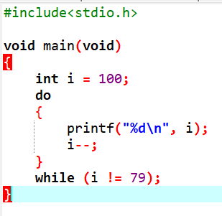

D. Write a program you have to find the factorial of given number.

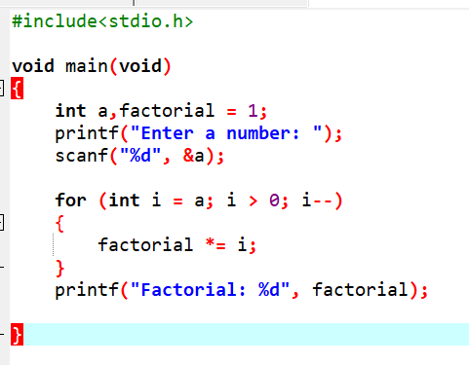

E. Write a program you have to print the Fibonacci series upto user given number

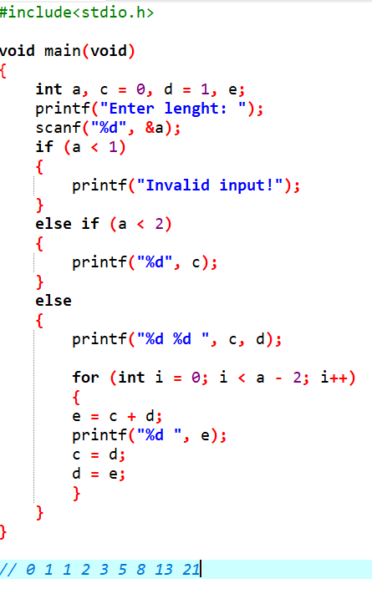

F. Write a program you have to print the table of given number.

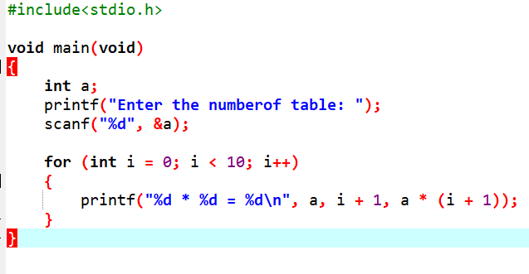

G. Write a program to print the number in reverse order.

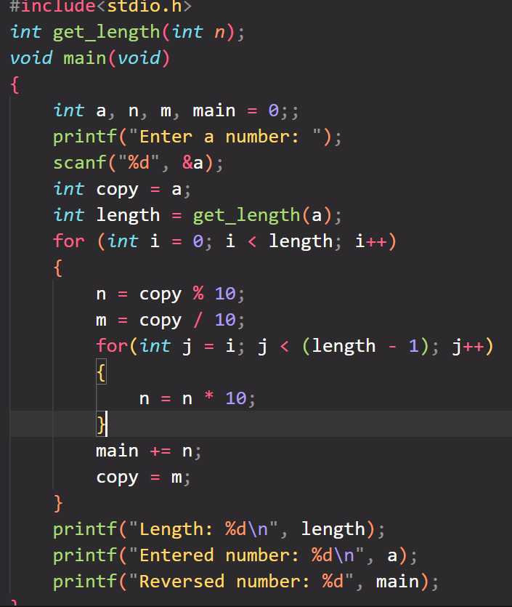

I. Write a program make a summation of given number (E.g. 1523 ans :- 11)

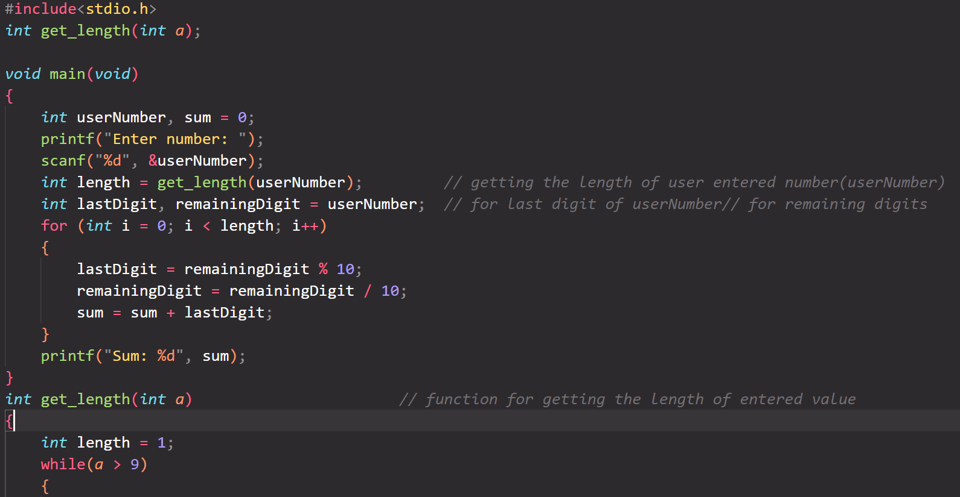

J. Write a program you have to make a summation of first and last Digit. (E.g. 1234 ans :- 5)

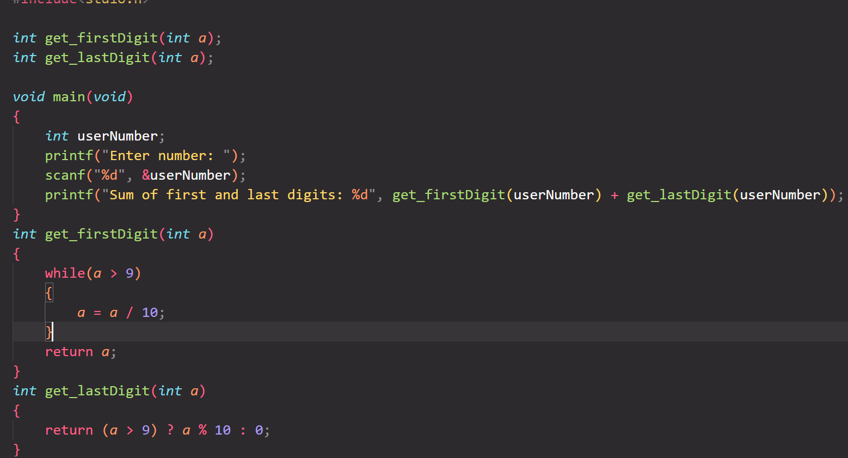

20. Pyramid Programs :-

1)

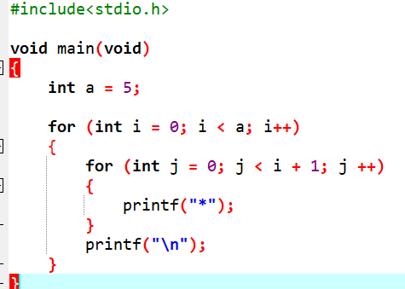

(2)

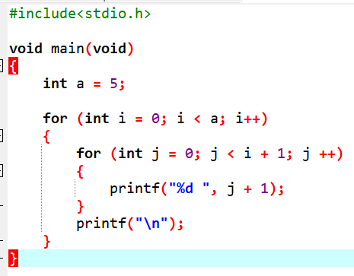

(3)

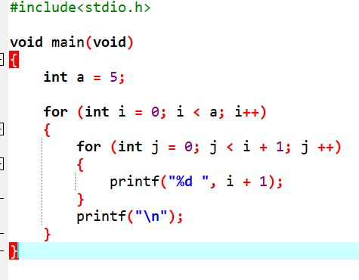

(4)

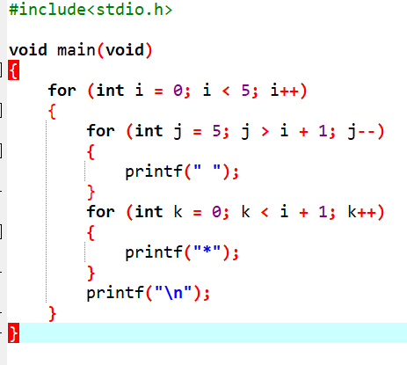

(5)

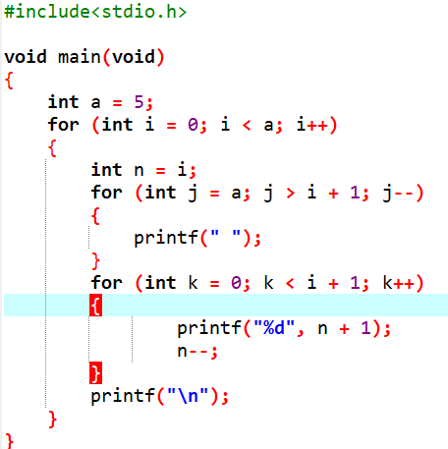

(6)



(7)

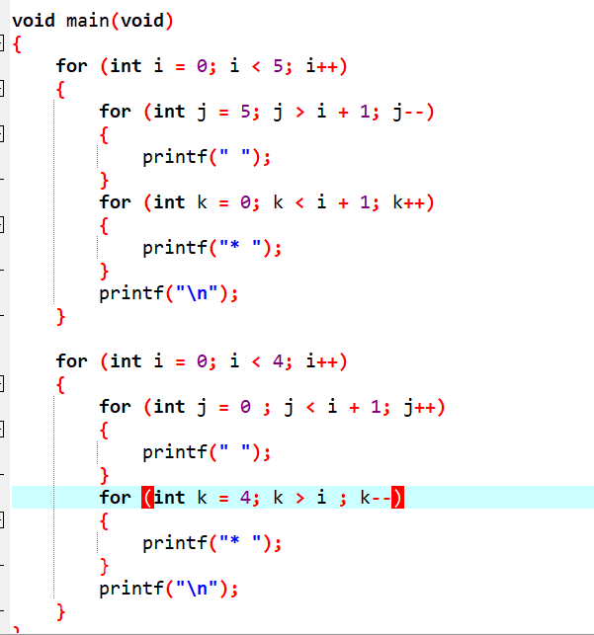

(8)

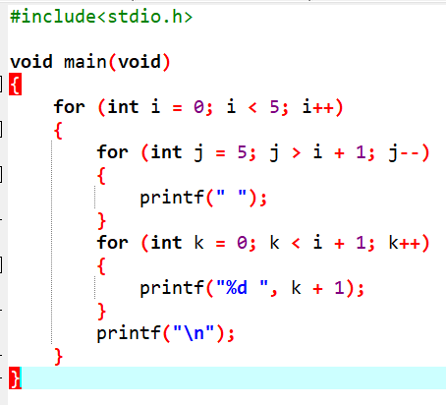

(9)

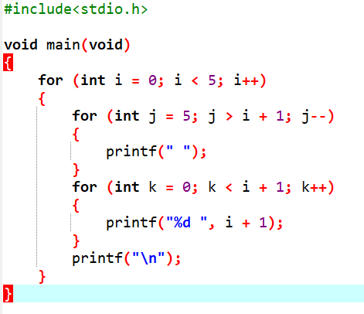

(10)

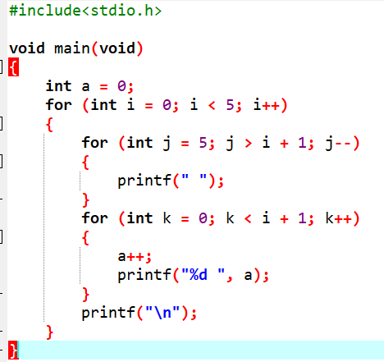

(11)

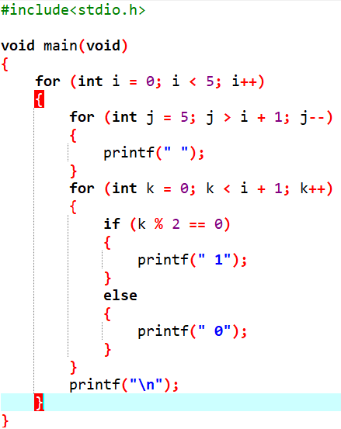

(12)

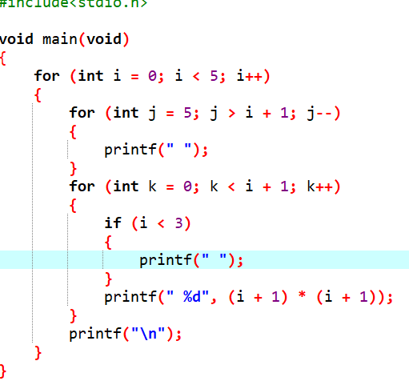

(13)

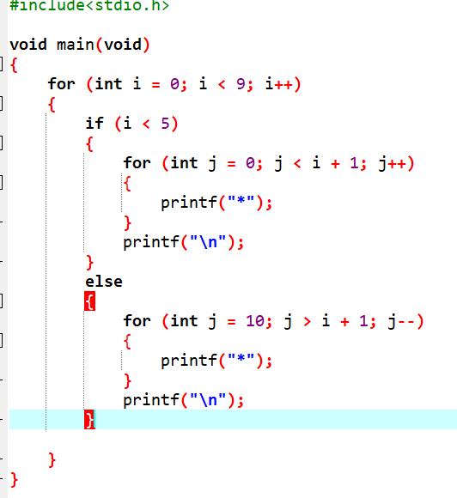

(14)

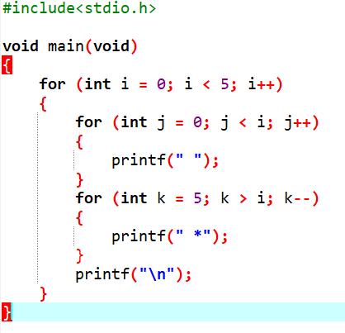

(15)

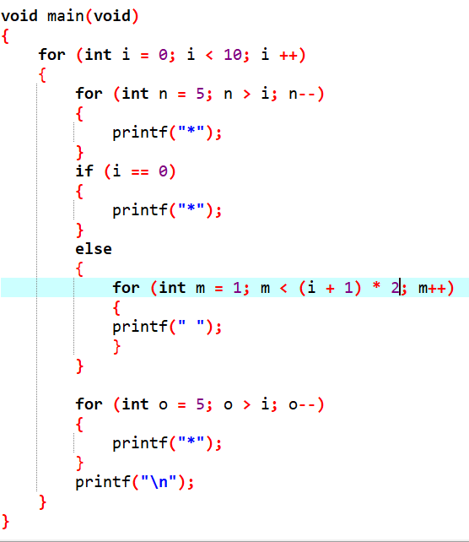

(16)

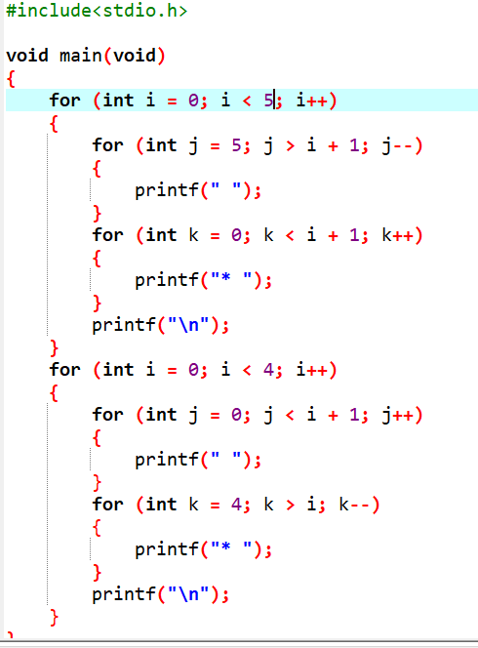

21. Write a program to enter five elements using Array and print it on screen

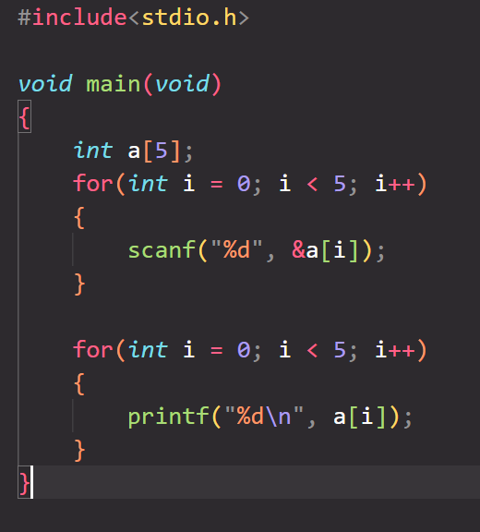

12. Write a program to enter ten elements using Array and find out the to count the total number of odd and even numbers

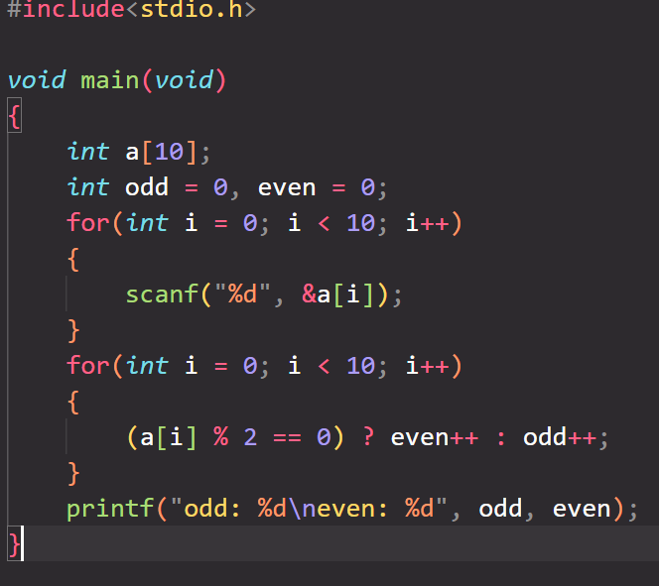

A1. Write a program to enter ten elements using Array and make a summation of the numbers and average of summation

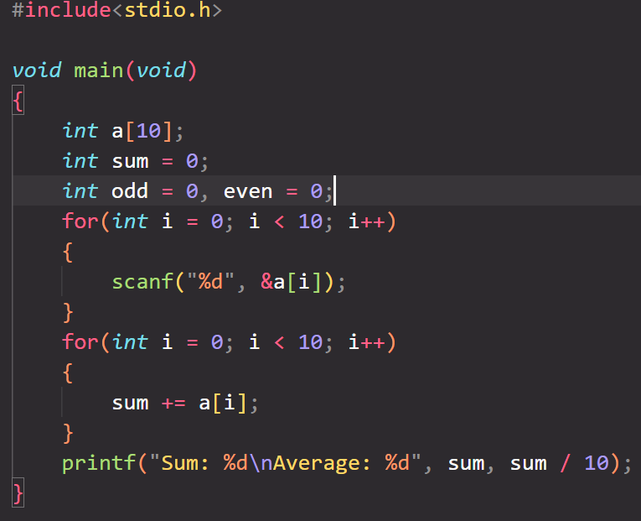

A2. Write a program to find out the max number from given 10 elements of array.

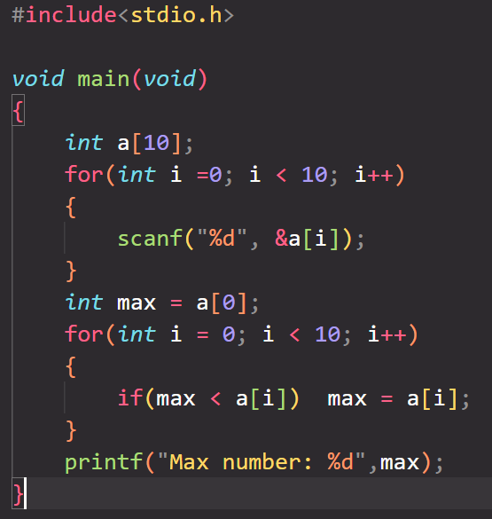

A3. Write a program to sort the array of 5 elements

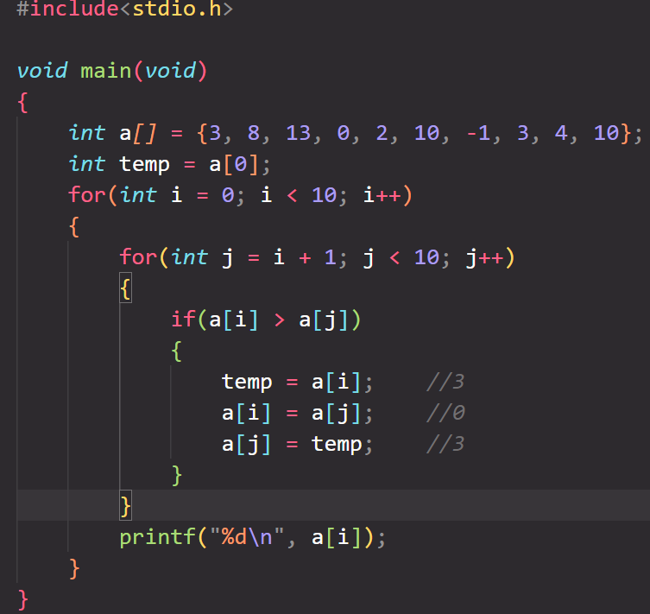

A4. Write a program to find out the second smallest number from the array.

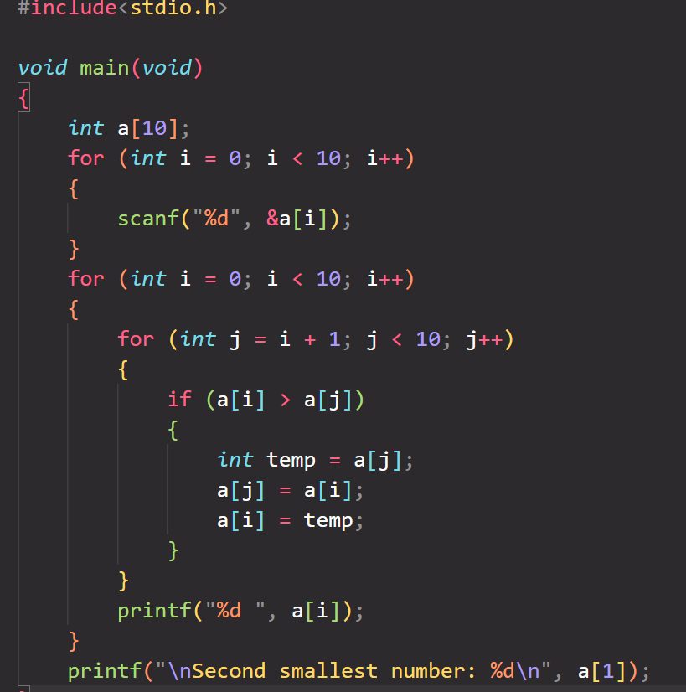

A5. Write a Program of find the element of given position from the array.

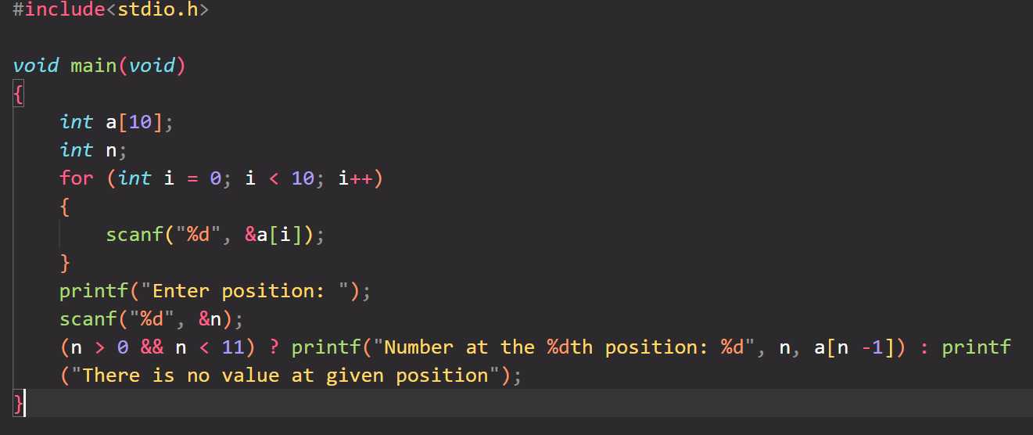

A6. Write a program to print the Matrix using 2-D Array.

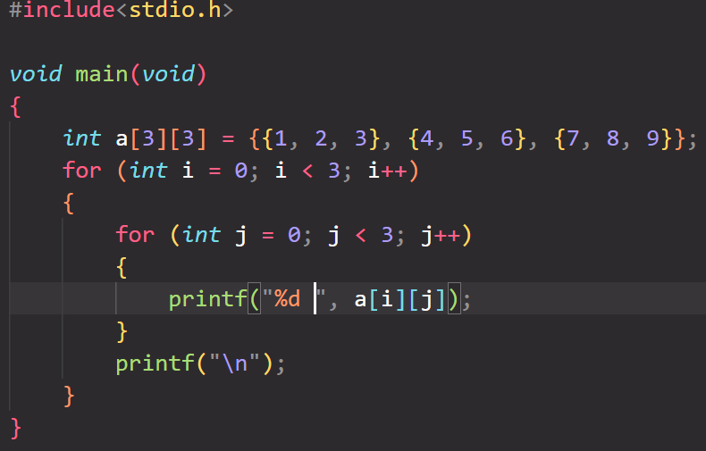

A7. Write a program of to make Addition of two matrix using 2-D Array.

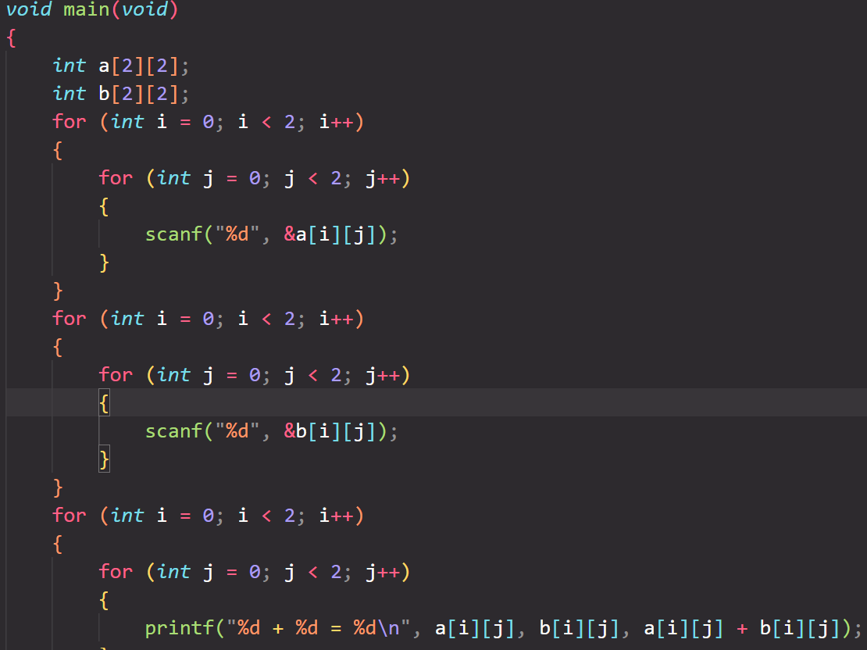

A8. Write a program of to make Subtraction of two matrix using 2-D Array.

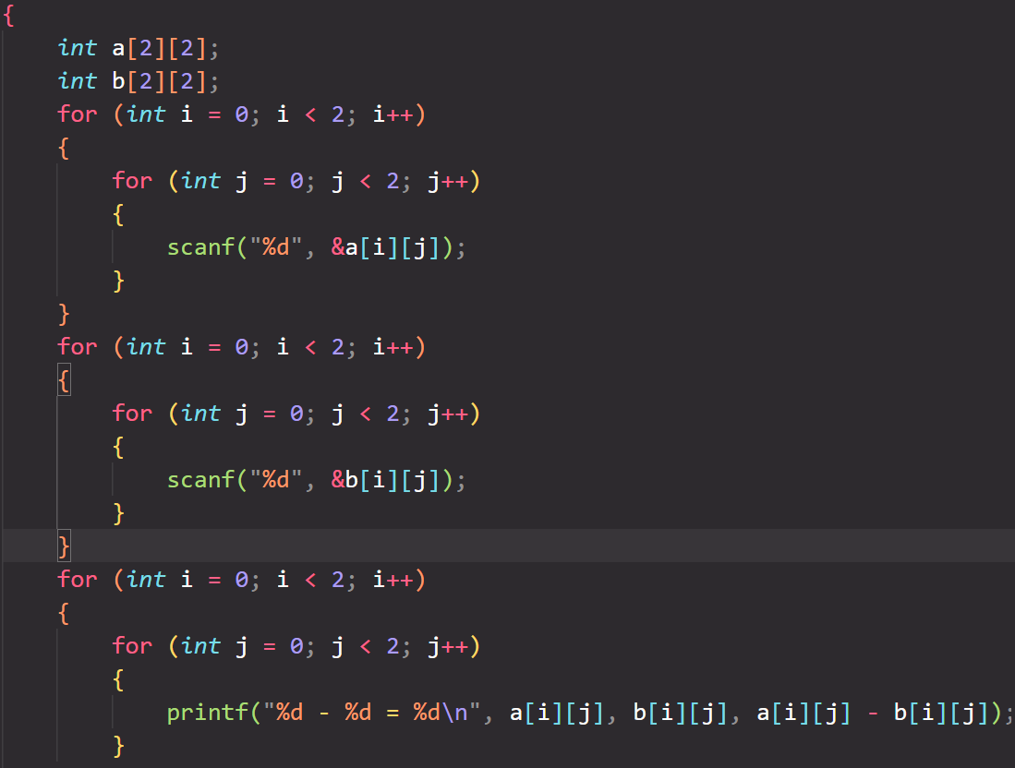

A9. Write a program of Multiplication make multiplication of two matrix using 2-D Array.

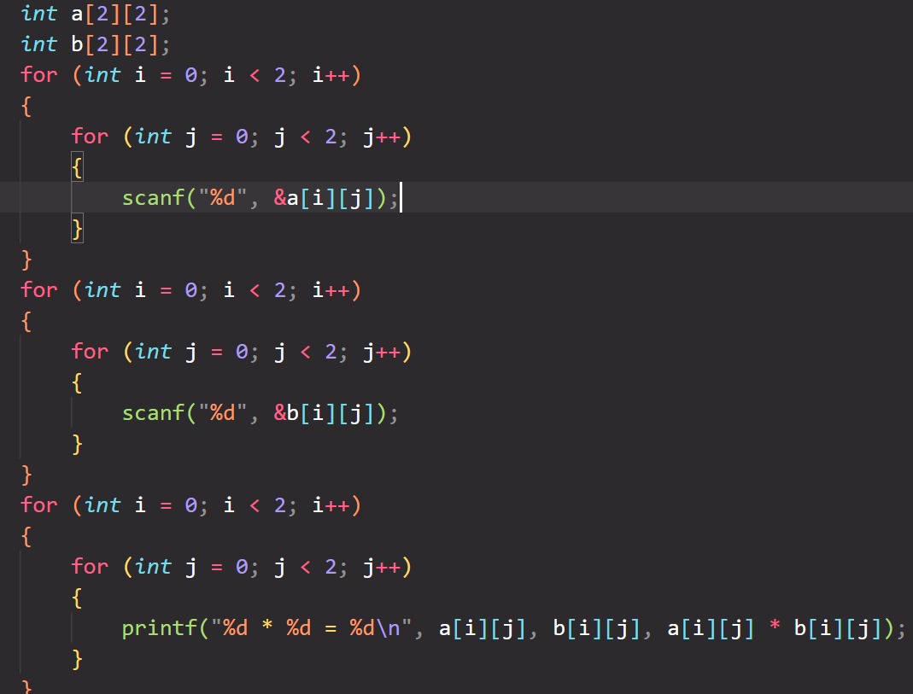

A10.Write a program to find out the Max number from given Matrix.

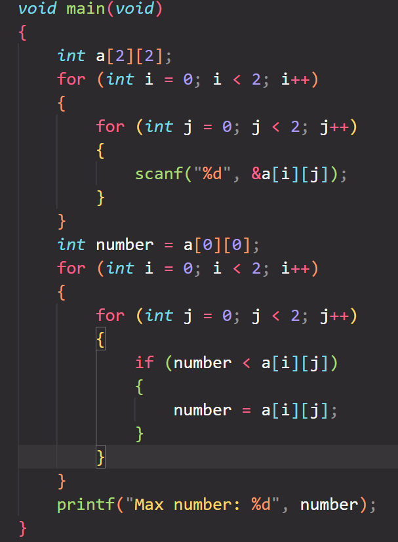

A11. Write a program to convert the string from uppercase to lower case and vice versa.

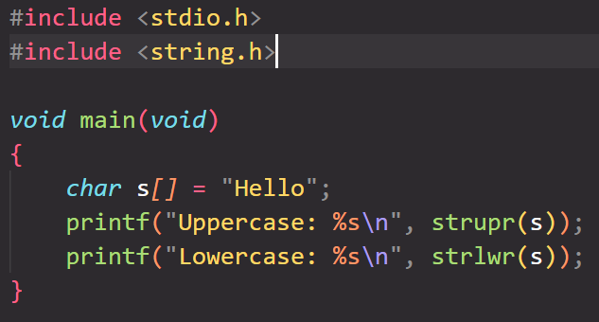

A12. Write a program to find out the length of given string without using string function.

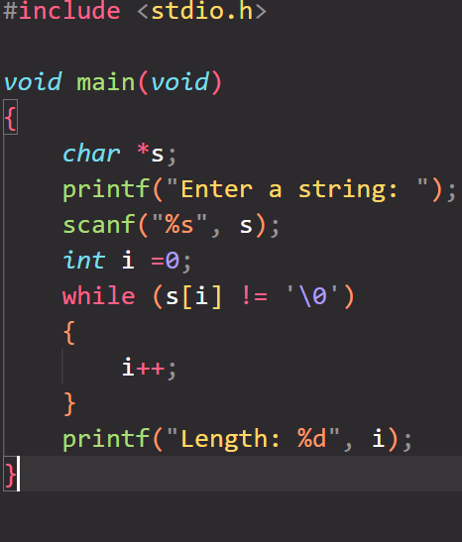

A13. Write a program to count the total number of word from given string without using string function.

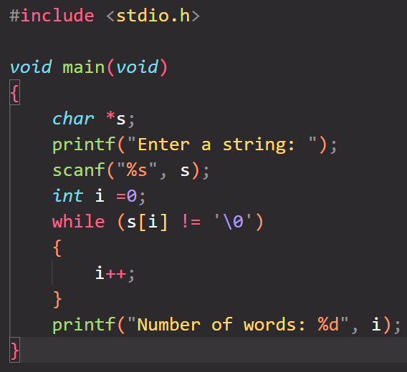

A14. Write a program to copy string from one string to another string without using string function.

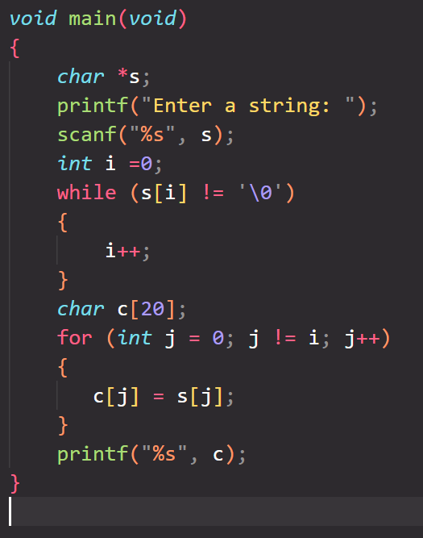

A15. Write a program to make string reverse and check the given string is palindrome or not without using string function.

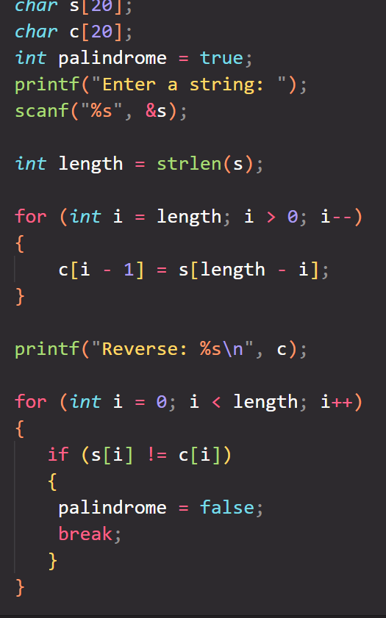

A16. Write a program concatenate the two string without using string function.

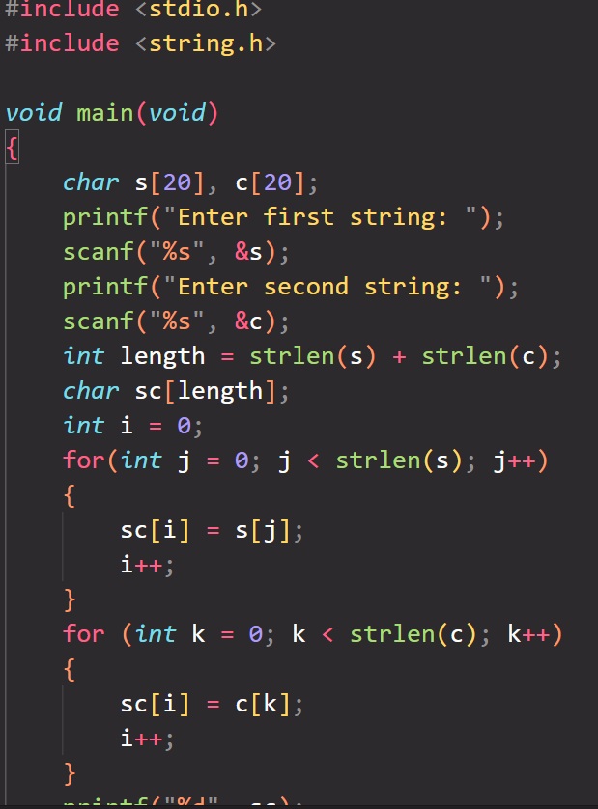

A17. Write a program to perform addition, subtraction, multiplication and division of two numbers using Function.

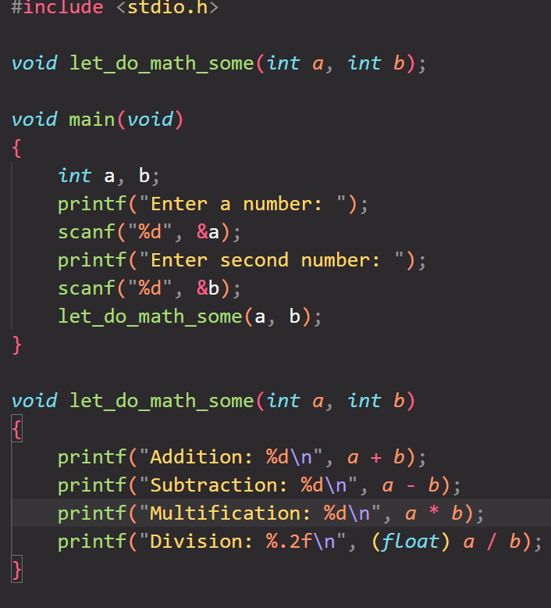

A18. Write a program to find out the Square and cube of given number using function.

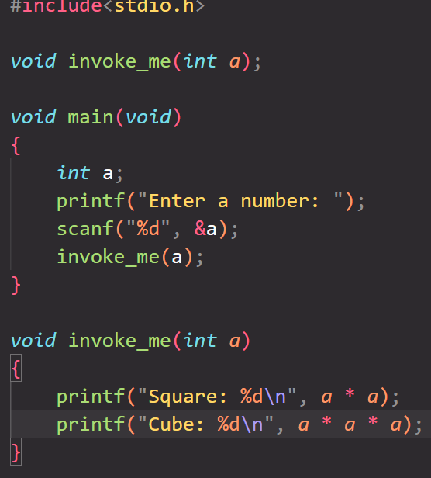

A20. Write a program to print the Fibonacci series using function.

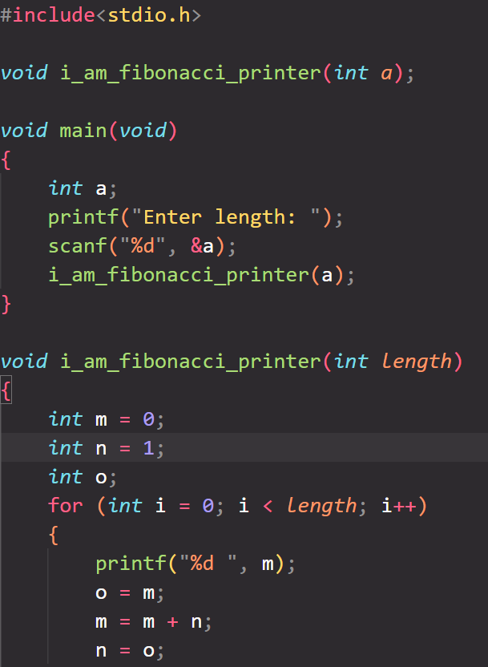

A19. Write a program to find out the factorial of given number using function.

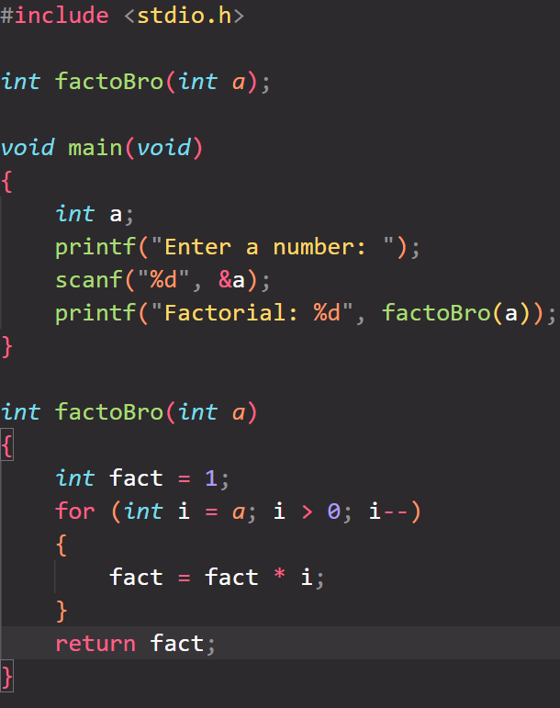

A21. Write a program to find out the max number from given array using function.

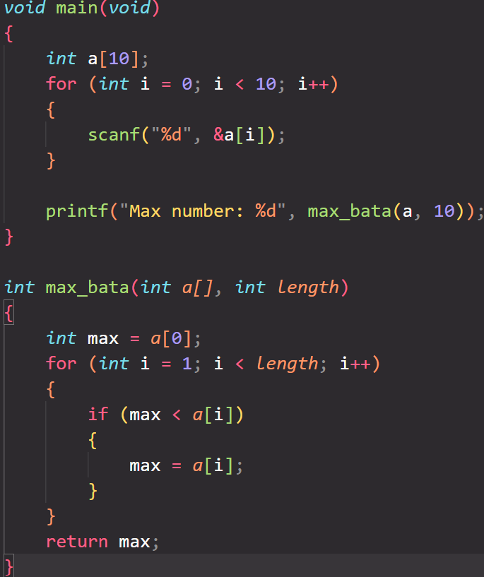

A22. Write a program to print the string in reverse order using function.

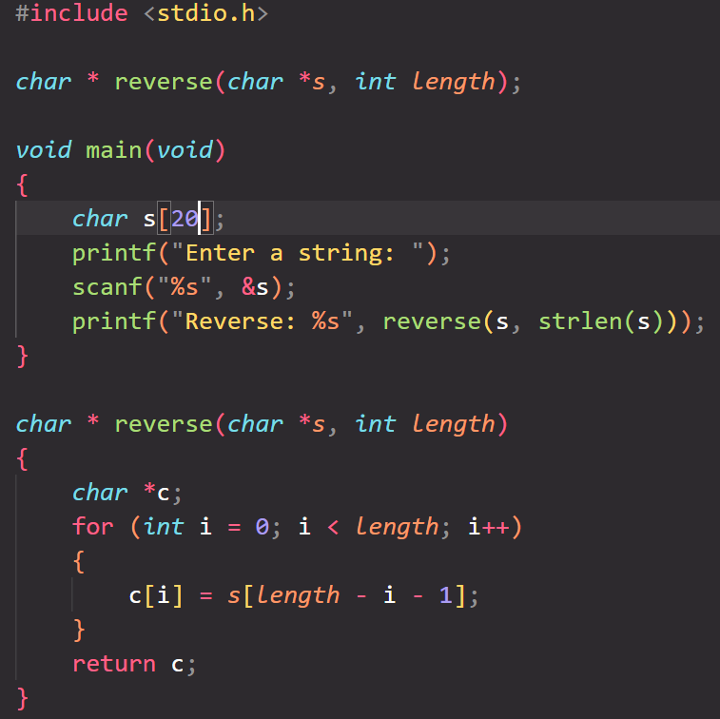

A23. Write a Program of Factorial using Recursive Function.

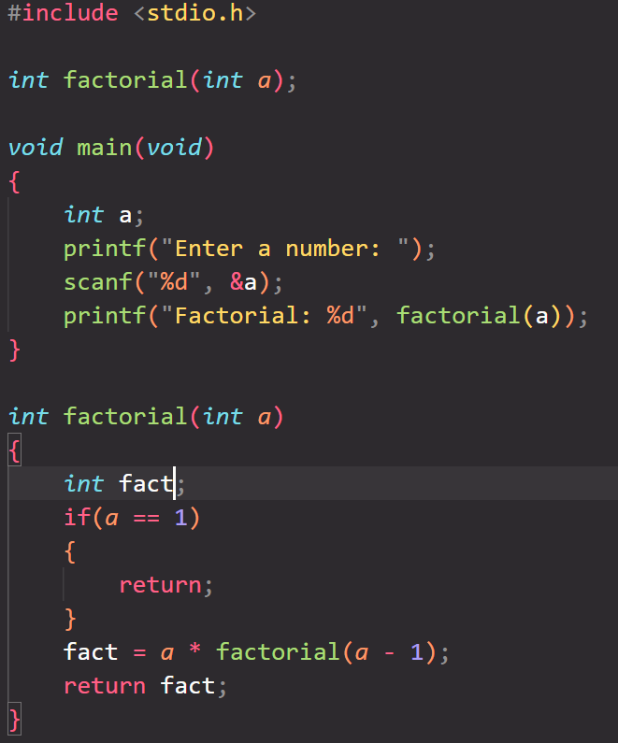

A24. Write a Program of Print a number and check the number is palindrome or not using recursive Function

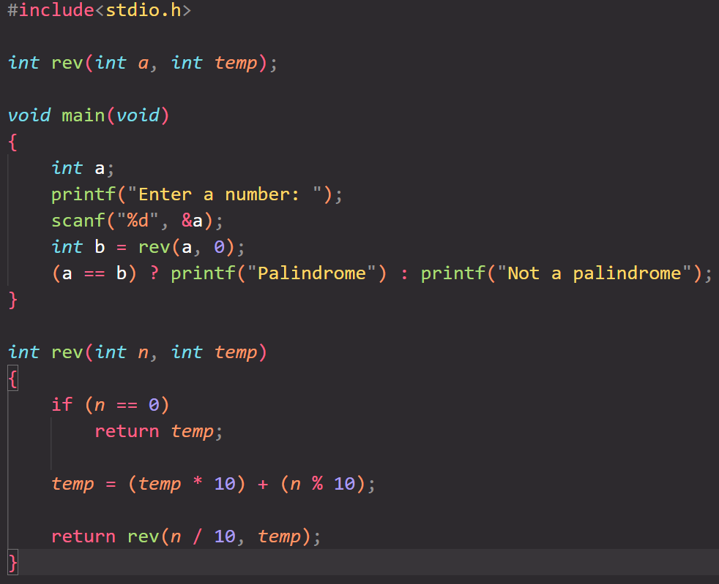

A25. Write a Program of Make a string reverse using recursive Function.

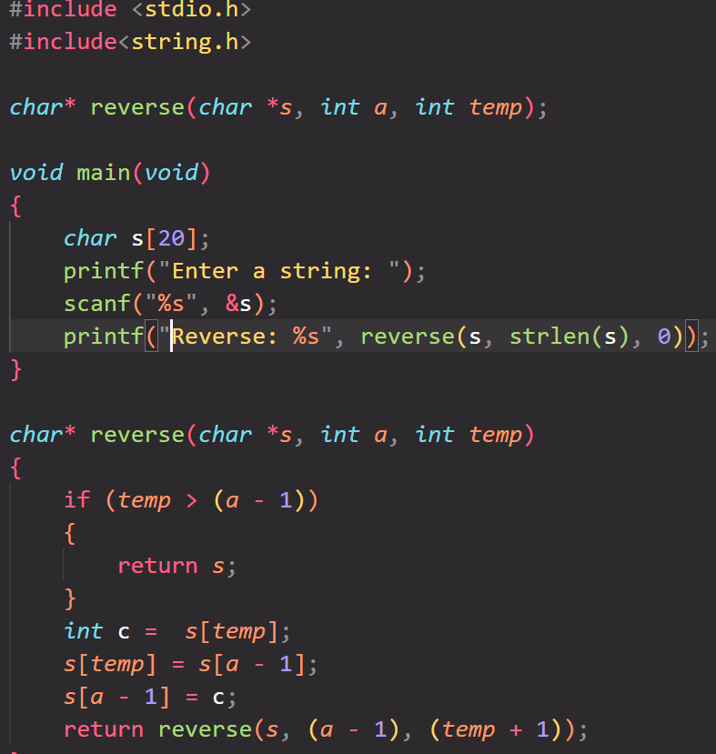

A26. Write a program of structure employee that provides the following information

- print and display empno, empname, address and age

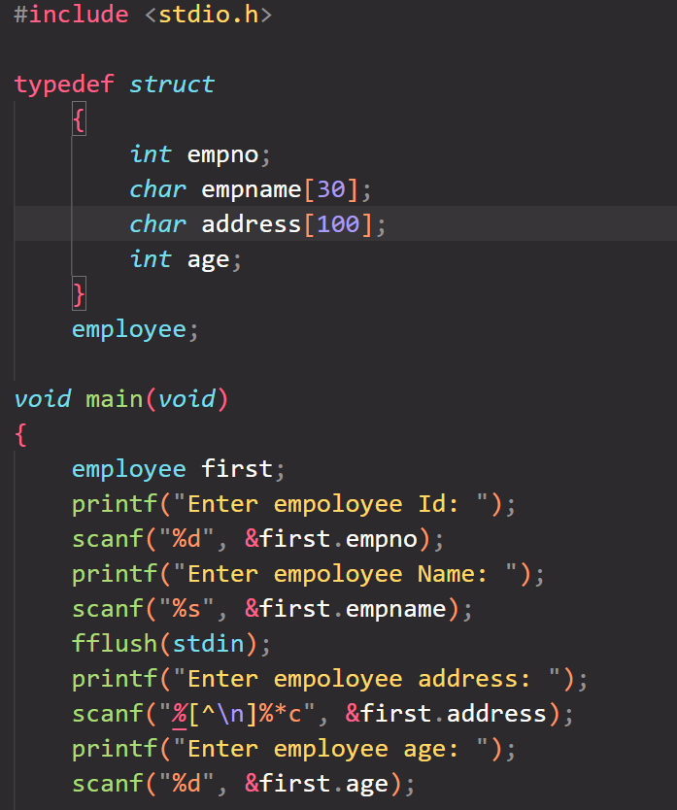

A27. Write a program of structure for five employee that provides the following information -print and display empno,empname,address and age

A29. Write program to make addition of two number using pointer

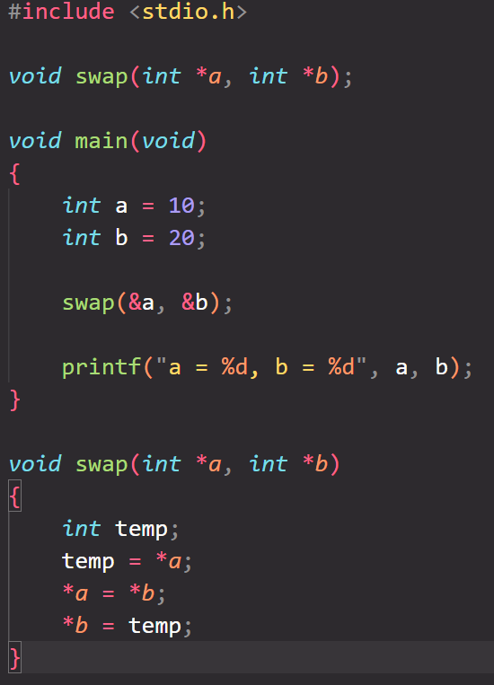

A30. Write a program to swap the two numbers without using third variable using pointer

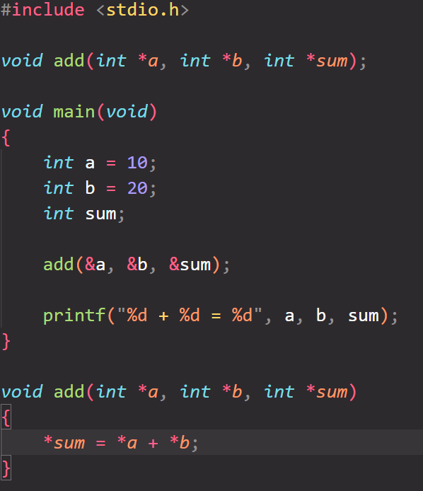

A31. Write a program to concatenate two string using pointer.